BASPCAN – the Association of England, Ireland,

Northern Ireland, Scotland and Wales for Child Protection
Promoting Positive Parenting to Help Make the World a More Peaceful Place
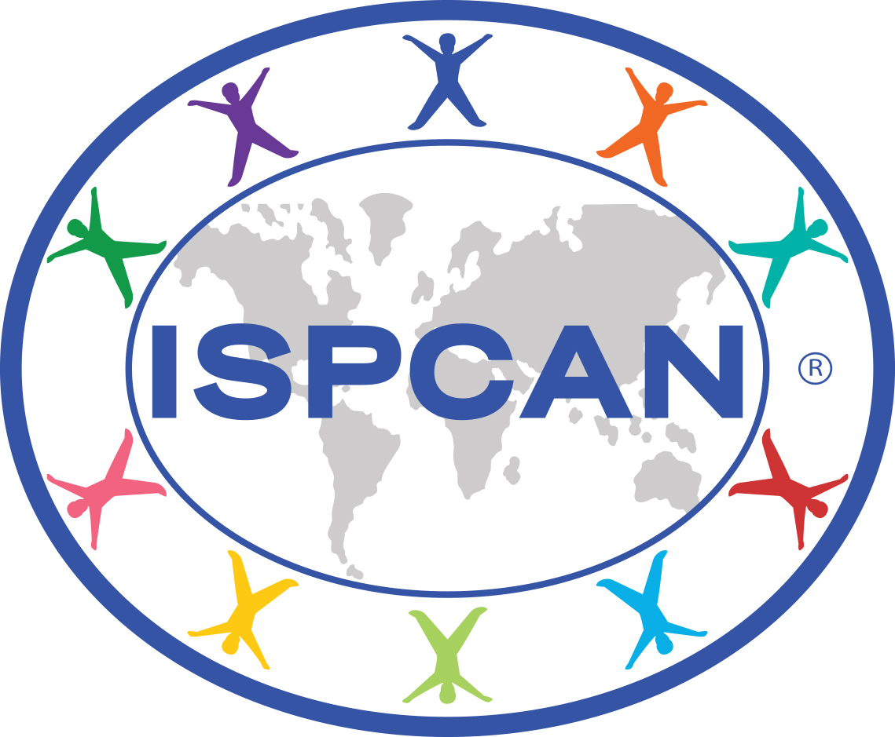

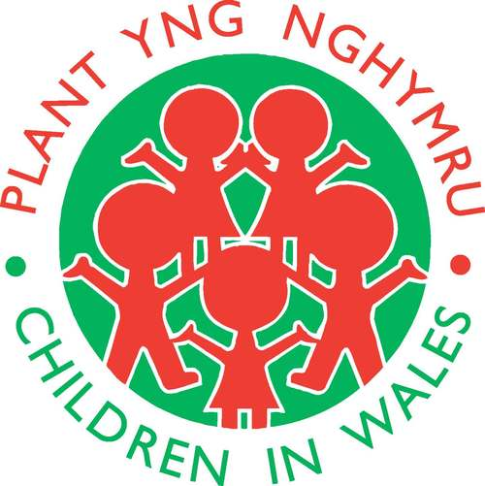


ISPCAN, BASPCAN, NSPCC Cymru/ Wales & Children in Wales would like to invite you to attend our joint conference at the Pierhead, Cardiff

Exploring the relevance to practice in Wales of an International Study on Promoting Positive Parenting

Sponsored by Lynne Neagle AM

Pierhead, Cardiff, Wednesday 14th March 2018
9.00am – 4.30pm

Speakers:
Minister for Children and Social Care, Huw Irranca-Davies AM
Professor Jane Barlow, Oxford University
Dr Arnon Bentovim, Child and Family Training
Jenny Gray, OBE, ISPCAN
Enid Hendry, BASPCAN
Speakers from Wales – to be confirmed
Des Mannion - NSPCC Cymru/Wales (Co-Chair Morning)
Catriona Williams, OBE - Children in Wales (Co-Chair Afternoon)

Supporting
Viv Laing – NSPCC Cymru/Wales
Geraldine Murphy - Children in Wales

Aims of the conference

- To explore the relevance to practice in Wales of findings from an international study by ISPCAN on promoting positive parenting
- To identify practical ways of improving parenting practice to achieve positive outcomes for children and young people in Wales.

Learning objectives
By the end of this event participants will be able to:
- identify how findings and recommendations from an international study by ISPCAN on promoting positive parenting relate to practice in Wales
- understand what is necessary for effective implementation of positive parenting interventions
- describe practical ways of improving parenting in day-to-day practice at primary, secondary and tertiary levels of intervention.

Audiences

- Professionals who coordinate and manage parenting support services.
- Professionals working directly with children and families from health, social work, early years, early intervention services, education and the independent and voluntary sector.
- Professionals with a responsibility for planning and commissioning services to promote child health and wellbeing, positive parenting and the prevention of child maltreatment.
- Coordinators on Public Service Boards in Wales.
- Educators and researchers working in the field of positive parenting and the prevention of child maltreatment.

PROGRAMME

Promoting positive parenting to help make the world a more peaceful place.

9.0am | Registration opens with refreshments
9.20am | Welcome and setting the context - why this conference now in Wales? Overview of day | Co-Chair – Des Mannion, NSPCC
9:30 | Address by Minister for Children and Social Care, Welsh Government | Huw Irranca-Davies AM
9.45am | ISPCAN’s international study on promoting positive parenting: Why it was commissioned, key findings and recommendations | Jenny Gray OBE and Enid Hendry
10.30am | Positive Parenting: overview on progress in Wales | Sally Holland, Children’s Commissioner for Wales -video recording  Other speakers from Wales to be confirmed
10.50 am | Refreshment break
11.05 am | Why focus on positive parenting? What makes us think positive parenting can help improve outcomes for children and prevent child maltreatment - the evidence base | Dr Arnon Bentovim
11.35 am | Facilitated table top discussions on findings and recommendations from ISPCAN study, and discussion of where further work needs to be done in Wales | Enid Hendry
12.20 pm | Prevention programmes from around the world that promote positive parenting – similarities and differences | Enid Hendry
12.35pm | Buffet lunch | To be confirmed
1.25pm | Welcome to the afternoon session from Co-Chair | Catriona Williams OBE, Children In Wales
1.30 pm | Beyond programmes: Effective Interventions | Jenny Gray
1.50 pm | The role of Parents Under Pressure in improving outcomes for children | Professor Jane Barlow
2.35 pm | Refreshment break
2.50 pm | Practical approaches to positive parenting at primary/ secondary/ tertiary levels | Speakers from Wales to be confirmed
3.40pm | Closing summary. What would it be helpful to take forward in Wales in further supporting positive parenting? | Co – Chairs
4.00pm | Close

Speakers and timings could be subject to change

KEYNOTE SPEAKERS:

Dr Arnon Bentovim
Arnon is a Child and Adolescent Psychiatrist and Director of Child and Family Training. He trained as a Psycho-Analyst and Family Therapist and worked at the Great Ormond Street Children's Hospital and the Tavistock Clinic, and was an Honorary Senior lecturer at the ICH-UCL. He is a Visiting Professor at the Royal Holloway University of London.
At Great Ormond Street, he shared responsibility for Child Protection and helped to initiate a number of services including the first Sexual Abuse Assessment and Treatment Service in the UK and a Child Care Consultation Service.
He was a founder member of ISPCAN and BASPCAN, and acted as a Specialist advisor to a House of Commons Select Committee which established the basic parameters of how Child Protection should be approached in the UK. He has presented papers and workshops at ISPCAN and BASPCAN conferences, acted as a book editor for the Journal of Child Abuse and neglect, and participated in working groups developing guidelines for working with sexual abuse, and contributed to the parenting guidelines recently published.
He was one of the group who pioneered the development of Family Therapy in the UK, and helped found the Association and Institute of Family Therapy, and was President of the International Family Therapy Association.
Research on Family Assessment at the Institute of Child Health formed the basis of the tools commissioned by the Department of Health and Department of Education to support the Assessment Framework. Child and Family Training was established to provide training and further developments in evidence based practice including the modular intervention approach to intervention. Research on treatment of sexual abuse and factors associated with sexually harmful behaviour was carried out at the ICH and GOS. He is chair of trustees of the Faithfull Foundation.

Professor Jane Barlow
Jane is Professor of Evidence-Based Intervention and Policy Evaluation in the Department of Public Health, and a Professorial Fellow of St Hilda's College, University of Oxford. Prior to moving to Oxford she was Professor of Public Health at Warwick Medical School, University of Warwick, and Director of Warwick Infant and Family Wellbeing Unit. In 2007 she was awarded an honorary fellowship of the Faculty of Public Health.
She is president of the Association of Infant Mental Health, editor in chief of Child and Adolescent Mental Health (CAMH), and a member of PreVAiL (Preventing Violence Across the Lifespan) research network. She has contributed to a number of NICE guidelines and co-chaired the development of the CYP IAPT curriculum 0 - 5 years.
Her programme of research focuses on the identification of effective methods of working to improve outcomes for high risk mothers and babies during the perinatal period, and she has undertaken extensive research on the effectiveness of interventions in reducing child abuse and neglect.

Jenny Gray
Jenny Gray OBE trained as a social worker in New Zealand and has been in children’s services social work, management and policy development since 1979. She joined the Department of Health, England in 1991 and led the development of new inspection methodologies. In 1995, Jenny was appointed as the professional adviser to the British government on safeguarding children. Jenny held this post until September 2012, since when she has been a social work consultant. She is a current Councillor and a Past President of the International Society for the Prevention of Child Abuse and Neglect (2012 – 2014) and a member of BASPCAN’s Editorial Board.

Enid Hendry
Enid Hendry has worked as a social worker in the voluntary and statutory sectors in various roles including in practice, training, research and strategy development. She was Director of Training and Consultancy for the NSPCC and deputy Director of Public Policy. She has published books, articles, reports and training resources on different aspects of child protection. Most recently she authored the ISPCAN report Promoting Positive Parenting to Prevent Violence against Children (2016). She is a BASPCAN Trustee and Chair of their Education, Learning and Policy Committee. She is also an Associate Editor of Child Abuse Review.

Des Mannion
Des Mannion is the NSPCC’s Head of Service for Cymru/Wales, a post he has held since 2010. Prior to 2010 Des has worked in a number of childcare posts both in Local Government and the Third Sector in Wales.
He is currently a member of the CAFCASS Cymru Advisory Committee, Pallial Strategic co-ordination Group and co-chaired the Welsh Neglect Project Advisory Group.
As National Head of Service Des is the public voice for NSPCC Cymru/Wales. In that capacity he has spoken on the campaign for equal protection, improved healthy relationship education and the significance of online safety. His professional development has been informed by his personal experience as a father of twins.

Catriona Williams, OBE
Catriona is currently the Chief Executive of Children in Wales which is the national umbrella membership charity for organisations and individuals from all disciplines and sectors working with children, young people and families. She has worked in the children and young people’s field all her professional life as a social worker, lecturer, researcher and manager of children’s services and was a leading member of the campaign to establish the first Children’s Commissioner in the UK and actively promoted a focus on combating child poverty in Wales. She has been a member of many Welsh Government working groups. Currently these include the Curriculum for Wales Stakeholder Group, the Together for Children and Young People Programme Board and the Improving Outcomes for Children Ministerial Advisory Group. On a UK level she was one of the 10 Commissioners on the UK Social Mobility and Child Poverty Commission until May 2016. Catriona has also been on the boards of several charities such as the Family and Parenting Institute and Play Wales. Currently she is Vice Chair of the Wales Council for Voluntary Action (WCVA) and co-chairs Voices from Care Cymru with a young person. Internationally, Catriona was the founder President of Eurochild (2001-2010), the pan European NGO funded by the European Commission that aims to combat child poverty and social exclusion across Europe. She was President of the International Forum for Child Welfare 2008-2012 and also Vice President of the European Social Platform of NGO’s in 2010-2012.

Promoting Positive Parenting to Help Make the World a More Peaceful Place
14th March 2018 – Pierhead, Cardiff

£100 Rate for members
ISPCAN/ BASPCAN/NSPCC/Children In Wales - membership no: __ __ __

£120 - Non-member rate

£50 - Student rate – criteria applies i.e. Proof of full time education

Please take payment by credit card [ ] debit card [ ]

Or book and pay online at http://www.baspcan.org.uk/events/

Card no...................................................................................Expiry date.........................................................

DELEGATE NAME AND MAILING ADDRESS..........................................................................................................
............................................................................................................................................................................
............................................................................................................................................................................
............................................................................................................................................................................
............................................................................................................................................................................

Contact Tel. number.......................................................................................................................................…

POST/PROFESSION...............................................................................................................................................

Email address……………………………………………………………………………………..……………………………………………………………

Employer/Organisation………………………………………………………………………..…………………………………………………………

INVOICE DETAILS FAO…….…………………………………………………………………….….….……………………………………………………………………..........

ADDRESS....................................................................................……………………………….………………………………………
............................................................................................................................................................................
............................................................................................................................................................................

Email Address……………….……………………………………………………………………...............................................................

Tel………………………………………….…………………………………… Fax………………………………………………………………………………

Please tick if you will require a vegetarian meal [ ] vegan meal [ ]
other requirement/disability [ ]…………………………….............................

BASPCAN reserve the right to make changes to the advertised programme. Booking conditions: Cancellations must be made 10 working days before the Conference date and an administration fee of £30 will be payable. After this date full fee is due. Substitutions can be made at any time by notifying the National Office. Individual memberships are not transferable.
Data protection: the information you provide will be held on a database to process your booking for the event. We may also use the information to keep you up to date with relevant conferences or events organised by BASPCAN. We do not pass your details on to any other companies for marketing purposes.

Book on line at http://www.baspcan.org.uk/events
Registered Charity 279119

