 North Wales Adult Safeguarding Report 

This form is to be used when there is reasonable cause to suspect that a person is an Adult at Risk;
An “Adult at Risk” for the purposes of this Part, is an adult who:
• Is experiencing or is at risk of abuse or neglect
• Has needs for care and support (whether or not the authority is meeting any of those needs),and
• As a result of those needs, is unable to protect himself or herself against the abuse or neglect or the risk of it

Date form Completed and sent: | Date(s) of Incident(s) if known:
Name of Individual:

Date of birth: | Gender: Male Female
Individual’s Current Address (please also list permanent address):  If appropriate, placement funded by: | Any other Adults / Children at Risk living at the property?  Yes No  If Yes what action has been taken:
Telephone Number: | Main Client Group:
  Older Person Mental Health
  Older Person
  Visual Impairment
  Hearing impairment
  Learning Disability
  Mental Health
  Physical Disability
  Substance Misuse
  Other
Marital Status:

Ethnicity:

Preferred Language:

Email:

Interpreter Required?

Yes No

If Yes please give details:
Next of kin:  Relationship:  Address:  Telephone number: |  | GP Details:  GP Name:  Surgery Address:  Telephone number:
About the individual believed to be at risk

Is the person at risk of abuse or neglect? | Yes/No
Describe the risks

Is there evidence that the person has been abused or neglected? | Yes/No
Describe what has happened

Is the person currently being abused or neglected? | Yes/No
Describe what is happening

Does the person have care and support needs? | Yes/No
Please describe their needs

Is the person able to protect themselves against the risk of abuse or neglect? | Yes/No
If No, please say why they are unable to protect themselves

Is the individual aware of the enquiry?

Yes No

If No, why?

Has the individual consented to the enquiry?

Yes No

If No, why is the referrer continuing with the enquiry?

Is there any evidence to suggest that the individual lacks mental capacity to consent/understand the concerns and/or process?

Yes No

If Yes, has an advocate been informed?

Yes No

If No, why?

Details of the formal/informal family or friend or advocate (if applicable):

IT IS EXPECTED THAT YOU HAVE DISCUSSED THIS SAFEGUARDING REPORT WITH THE INDIVIDUAL OR THEIR ADVOCATE AND MADE THEM AWARE YOU ARE REPORTING THE CONCERN TO ADULT SOCIAL CARE. IF YOU HAVE NOT DONE SO, PLEASE STATE WHY:

2 About the alleged abuse
Type of Alleged Abuse (tick all relevant boxes)

Financial/Material
Neglect
Physical
Sexual
Emotional/Psychological

Describe the alleged abuse or neglect: (body map)

How long has the alleged abuse been taking place? | Where did the alleged abuse occur?
When did the alleged abuse occur?
How often and to what degree has the abuse been taking place?

What is your view of the impact the abuse is having on the individual?
What steps have been taken to safeguard/protect the individual and by whom?
(Include how the risk has been managed, what others have been informed – including statutory agencies, GP, Police, etc.):

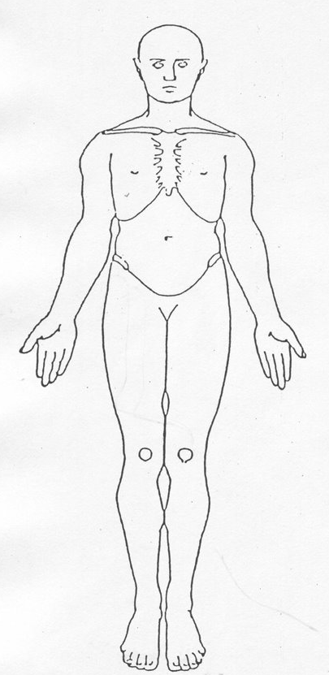  Please highlight any physical injuries. | 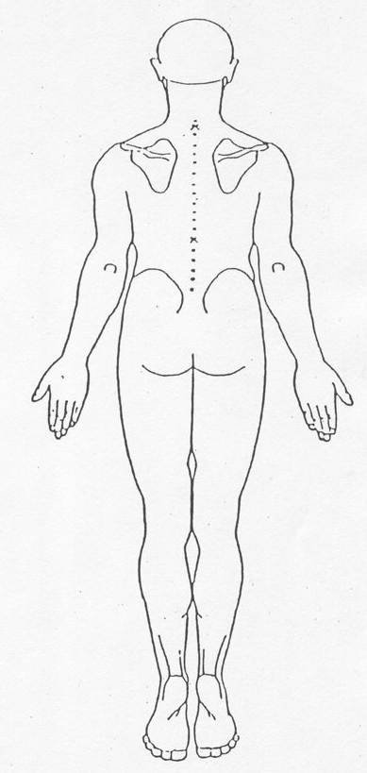

What are the individual’s views, wishes and feelings about the Safeguarding Concern?
(To include any actions they have taken or would like to be taken):

3. About the person(s) allegedly responsible for the abuse:

Unknown at present:
Name: | Address:
Telephone Number: | Date of Birth:
Age: | Relationship to Alleged Victim:
Do they have capacity to understand their actions?

Yes No Don’t know

Employer: (if paid worker)
Does the alleged perpetrator provide Care & Support for the individual?

Yes No Don’t know
Does the alleged perpetrator have care and support needs?

Yes No Don’t know
Is alleged perpetrator aware of the referral?

Yes No Don’t know

Note: If more than one alleged perpetrator has been identified please provide details in Section 7.

4. About the person(s) who witnessed the incident(s):

Name: | Address:
Telephone Number: | Relationship to victim (if any):

Note: If more than one person has witnessed the incident(s) please provide details in Section 7.

5. About the person who first reported the concern:

Name: | Address:
Tel No: | Occupation/Relationship:
Date/Time report:
Does the referrer wish to remain anonymous? Yes No

If yes, please state why:

6. This form was completed by:

Name: | Time/Date completed:
Agency/Company: | Designation:
Telephone number: | E-mail address:
Where applicable, details of countersigning line manager:

Name: | Designation:
Time/Date countersigned: | E-mail address:

7. Additional Information

Please send this form ‘for the URGENT attention’ of ONE of the following:

The Conwy Customer Access Team wellbeing@conwy.gov.uk
The Wrexham Initial Response Team irt@wrexham.gov.uk
The First Contact Team, Flintshire ssduty@flintshire.gov.uk
Gwynedd’s Adult Advice and Assessment Team cynghoriasesuoedolion@gwynedd.llyw.cymru Denbighshire SPOA spoa@denbighshire.gov.uk
Anglesey - The Adult Services Duty Team asduty@ynysmon.gov.uk
Betsi Cadwaladr University Health Board BCU.AdultSafeguarding@wales.nhs.uk

Date Ratified: 30 March 2017

Review Date: 30 March 2018

Version | Consultation Completion Date | Description of Reason for Change | Author | Authorisation | Date Issued




