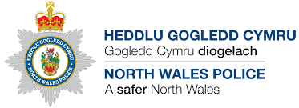

North Wales Police

PRUDiC

Templates for Meetings

Invitees

Organisation | Name | e-mail
Police (senior investigating officer)
(chair)
Minute taker
Social Services, Senior Manager
Organisation | Name | e-mail
Consultant Paediatrician
Named Doctor, Safeguarding Children
Head of Safeguarding Children
Paediatric Pathologist (Case Discussion Meeting Only) (If required)
Community Midwife/Health Visitor/School Nurse (if appropriate)
Organisation | Name | e-mail
GP
Education Representative
Coroners Officer
WAST
NWF&RS
Probation Rep (if required)
Organisation | Name | e-mail
Adult/Disability Team (SS) (If required)
Women’s Aid/IDVA (if required)
Drug and Alcohol Service (if required)

